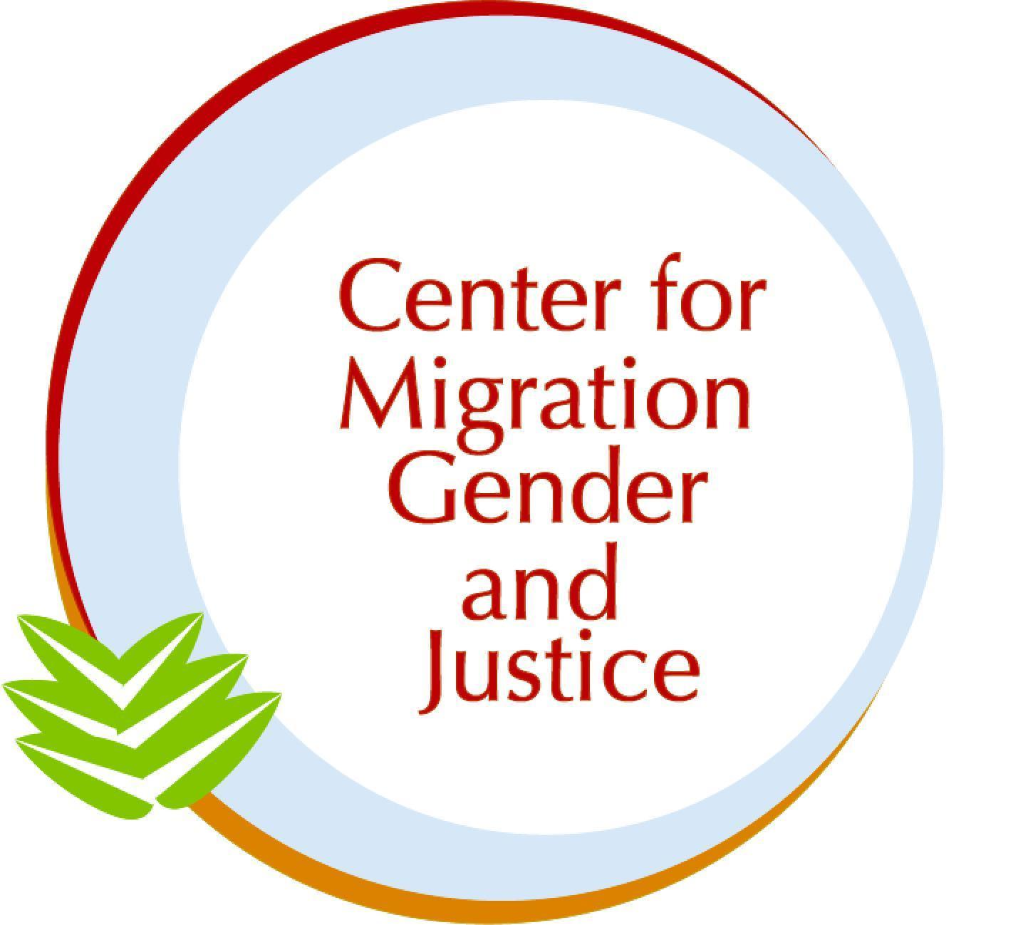

Submission to the Committee on Migrant Workers (CMW)

SHADOW REPORT: Benin

November 1, 2024

Authors: Stacy Ogembo and Dr. Lara-Zuzan Golesorkhi

The Center for Migration, Gender and Justice is a migrant- and women-led non-profit, non-governmental organization that addresses human rights at the intersection of migration and gender through research, advocacy, and education. Within our areas of expertise, this report speaks to Benin’s implementation of the Convention on the Protection of the Rights of All Migrant Workers and Members of Their Families in light of the Committee’s 39th session (2-13 December 2024). Throughout the report, the names of any alleged victims, witnesses, and perpetrators have been anonymized, and no photographs of alleged victims, witnesses, or perpetrators have been included.

In this report, we employ a working definition of migrant as a person who moves away from their place of usual residence, whether within a country or across an international border, temporarily or permanently, and for a variety of reasons. The term includes a number of legal statuses of persons. We identify the specific legal status when necessary and/or to amplify particular experiences.

Migration and Gender in Benin’s Initial Report:

Benin, due to its political stability and potential for economic growth, plays a key role in West Africa’s migration dynamics as a country of origin, transit, and destination. With a population of 12.1 million, Benin hosts 394, 276 international migrants (UNDESA, 2020). This accounts for approximately 3.3% of the country’s total population. The primary countries of origin include Togo, Nigeria, Niger, Côte d’Ivoire, and Ghana. Migrants largely reside in the southern regions, particularly in Littoral, where many are employed in the commerce sector. In 2013, the employment rate amongst migrants was 59.6% (Ibid.).Women make up 52.9% of all migrants in Benin as of 2020 with the majority of them falling within the working-age group of 20-64 years old (IOM, 2023; Integral Human Development, 2022). Regarding displaced populations in the country, the UN Refugee Agency (n.d.) reports that Benin had registered 16,141 refugees, 981 asylum seekers, and 8,785 internally displaced persons in 2024.

In terms of emigration, data show that 5.65% of Benin’s population had left the country in 2019 with males outnumbering females (UNDESA, 2020). Within Africa, the primary destination countries for Beninese emigrants are Nigeria (55.35%), Togo (10.82%), and the Ivory Coast (10.53%), whereas those who ventured beyond the African continent predominantly reside in France (64.26%), followed by Italy (8.46%), Canada (8.42%), and Germany (7.30%). Most Beninese emigrants are employed in low-skilled sectors and main occupations include agricultural, forestry, and fishing laborers (20.1%), plant and machine operators (19.7%), as well as direct service personnel, traders, and salespersons (10.7%).

Benin’s fundamental legal framework that protects the rights of migrant workers is based on its Constitution (Act No. 2019-40) which grants non-nationals the same rights and freedoms as Beninese citizens under Article 38. The Labour Code (Act No. 98-004) further regulates migrant workers’ rights such as access to employment, social security, education and vocational training, protection from unfair dismissal, as well as participation in trade unions. Other supplementary national laws include Act No. 86-012 which establishes foreign national regulations, the Children’s Code (Act No. 2015-08) which protects child migrants, and Decree No. 2006-066 which regulates the accommodation of foreign nationals.

Outside of the Convention on the Protection of the Rights of All Migrant Workers and Members of Their Families, Benin has ratified the following additional international conventions that are relevant to migrant workers: International Covenant on Civil and Political Rights, International Covenant on Economic, Social, and Cultural Rights, ILO Migrant Workers (Supplementary Provisions) Convention, African Charter on Human and Peoples’ Rights, ILO Equal Remuneration Convention, ILO Tripartite Consultation (International Labour Standards) Convention, and Convention on the Elimination of All Forms of Discrimination against Women.

Furthermore, Benin has begun engagement with the Global Compact for Safe, Orderly, and Regular Migration (GCM), notably through its participation in the August 2024 meeting to review the draft Plan of Action for implementing the GCM across Africa. Regionally, Benin is a member of the Economic Community of West African States (ECOWAS) and the West African Economic and Monetary Union (UEMOA), both of which promote the free movement and social protection of migrant workers.
Despite these legal-institutional frameworks in place, the intersection of migration and gender largely remains overlooked in the state party report as it pertains to labor protections of women, girls, LGBTQIA+, and gender-diverse migrants.

Based on an analysis using our Gender-Migration Index (GMI), a guidance tool for gender-responsiveness and migrant-inclusion in policy, we find that there is moderate mention of, engagement with, and commitment to gender dynamics in CMW/C/BEN/1. The 20-page-long document refers to women, girls, sex(es), and gender-based violence (GBV) 13 times in total with a complete absence of reference to LGBTQIA+ and gender diverse migrants as well as limited explicit gender-responsive policies and programs.

For example, while the state report highlights the promotion of mutual respect between the sexes, the condemnation of violence and gender inequality, and the institutionalization of the New Recruitment Law, which protects the rights of migrant workers and shields them from all forms of discrimination, including discrimination based on sex, other existing policies and programs remain vague in regards to gendered labor protections of migrant workers (p.10-22). This is of particular concern in policy areas such as informal labor, gender-based violence (GBV), and trafficking.

Many migrant workers in Benin are employed in the informal sector and have undocumented status, rendering them particularly vulnerable to labor rights violations. These vulnerabilities are often heightened for women and low-skilled workers. Similarly, although Benin has adopted Act No. 2011-26 to prevent and penalize violence against women and girls, enforcement mechanisms appear lacking. The only noted effort towards GBV prevention, mitigation, and response is the establishment of an Action Plan. Provisions for shelters, legal aid, and psychological support systems are not mentioned. Furthermore, the absence of legal recognition and protections for LGBTQIA+ and gender-diverse migrants presents a significant gap in Benin’s labor protection frameworks and anti-trafficking policies.

Based on the information provided, we recommend that the Committee ask the Government of Benin the following questions and that these enquires are included in the Concluding Observations:

- How does Benin plan to improve the monitoring and enforcement of its laws in protecting migrant workers, with a particular focus on gender-responsive measures?

- With the regional Plan of Action for the GCM set for adoption in December, what are Benin’s aspirations in support for this Plan relative to labor migration? Specifically, what measures are intended to address gender-specific challenges within the labor sector as part of its alignment with GCM principles?

- Considering the absence of legal protections for LGBTQIA+ and gender-diverse migrant workers, what steps is Benin taking to address discrimination based on sexual orientation and gender identity, in line with the Convention’s Article 7 (non-discrimination)?

Informal Labor

The state party report acknowledges significant challenges in protecting migrant workers in the informal sector. For instance, CMW/C/BEN/1 notes on page 9: “The size of the informal sector is a major obstacle to the implementation of the Convention. This sector employs a great many undocumented migrants, whose rights are violated and who cannot complain because they wish to preserve their livelihoods.”

These protection gaps prevail despite Benin’s record of a range of existing national and international frameworks (see above). Of note here are the New Recruitment Law and the planned National Labour Policy for which further inquiry is required (see below). On this account, it must be considered that migrant workers in the informal sector are mainly concentrated in the agricultural, industrial, and commerce fields (Integral Human Development, 2022). In these fields, gender dynamics need to be acknowledged and the unique experiences of women, girl, LGBTQIA+, and gender diverse migrant workers need to be adequately addressed. Also, the domestic sector deserves more attention here with high levels of informality; this must be reconciled against the lack of ratification of the Domestic Workers Convention (ILO C189).

Based on the information provided, we recommend that the Committee ask the Government of Benin the following questions and that these enquires are included in the Concluding Observations:

- What specific measures are being taken to ensure the rights of migrant workers in the informal sector in alignment with Article 25 of the Convention which guarantees equal treatment in terms of working conditions?

- Can you provide updates on the progress of enforcing the New Recruitment Law, particularly in safeguarding migrant workers from gender discrimination? And, what is the current status of the National Labour Policy and when is it expected to be adopted by the Council of Ministers?

- Does Benin plan to ratify ILO C189 as means of strengthening gendered labor protections?

Gender-Based Violence

A connected concern to the informal sector in terms of gendered labor protections is GBV. Notably, GBV is mentioned only once in CMW/C/BEN/1 on page 11: “Action plans and best practices to combat racial discrimination, xenophobia, intolerance, and gender-based violence have also been established in Benin.”

The state report further emphasizes that the Government of Benin passed Act No. 2011-26 to prevent and penalize violence against women and girls. This falls in line with Benin’s ratification of the Convention on the Elimination of All Forms of Discrimination against Women. Yet, as the US Department of State found in a 2012 report (a), enforcement challenges persist in the implementation of Act No. 2011-26 due to limited police training, official corruption, and victims’ reluctance to report cases due to social stigma and fear of retaliation. These challenges result in many cases being downgraded to misdemeanors, undermining accountability and protection for GBV survivors.
Pertaining specifically to the labor market, it must be noted that Benin has not ratified the ILO Convention on Violence and Harassment in the World of Work (C190). ILO C190 holds provisions that address the identified enforcement challenges in GBV prevention, mitigation, and response while also covering gendered labor protections in the informal sector.

Based on the information provided, we recommend that the Committee ask the Government of Benin the following questions and that these enquires are included in the Concluding Observations:

- What mechanisms are in place to enforce Act No. 2011-26 in efforts to prevent and penalize violence against women and girls?

- Does Benin plan to ratify ILO C190 as means of strengthening gendered labor protections?

- How is Benin working to improve the reporting mechanisms for GBV, particularly for migrant women workers, who may fear retaliation or loss of employment?

Trafficking

Benin is a party to the Protocol to Prevent, Suppress and Punish Trafficking in Persons, Especially Women and Children and has entered into bilateral agreements with Nigeria and the Republic of the Congo to prevent, punish, and eliminate trafficking. Key institutions that play a vital role in this context include the Ministry of Social Affairs and Microfinance, which focuses on child protection, women’s rights, and combating trafficking, as well as the Central Office for the Protection of Minors and Families and for the Prevention of Human Trafficking, which is dedicated to safeguarding minors, supporting families, and preventing trafficking. Additionally, Benin’s Criminal Code (i.e. Article 372) explicitly prohibits forced labor, exploitation, and all forms of trafficking.

Despite being a chief concern when it comes to gendered labor protections, CMW/C/BEN/1 does not explicitly mention existing enforcement mechanisms in place to monitor trafficking activities and to ensure compliance with anti-trafficking laws. This is alarming because there is evidence to suggest that women and girls from Nigeria, Guinea, Togo, and Niger are forced into prostitution and domestic servitude (UNDESA, 2020). Other research reveals that Benin has not provided adequate protective services to adult trafficking survivors and lacks disaggregated data to track care for child survivors of commercial sexual exploitation (US Department of State, 2012b). Notwithstanding the prevalence of trafficking, especially in Cotonou, where most identified victims are young girls subjected to domestic servitude or sex trafficking, penalties for trafficking offenses are not stringent (Ibid.).

Benin’s move towards the implementation of the GCM offers a space for consideration in this context as Objective 10 of the Compact directly speaks to preventing, combating, and eradicating trafficking in persons. The upcoming adoption of the regional Plan of Action for the GCM set for December is thus of utmost importance.

Based on the information provided, we recommend that the Committee ask the Government of Benin the following questions and that these enquires are included in the Concluding Observations:

- What mechanisms are in place for collecting and analyzing data on trafficking, including disaggregated data by gender and type of associated labor exploitation?

- Given the provisions of the Convention and the GCM regarding trafficking, how does Benin plan to improve cross-border collaboration (beyond existing bilateral agreements) in addressing gendered labor protections?

- What efforts are being made to enhance enforcement against trafficking in persons and how does Benin ensure that survivors have access to support services and legal remedies?

References

Integral Human Development. (2022). Migrants & Refugees Section: Benin. Retrieved October 24, 2024, from https://migrants-refugees.va/country-profile/benin/

IOM. (2023). Benin. Retrieved October 24, 2024, from https://www.iom.int/countries/benin

IOM. (2012). Benin remains a country of emigration and destination, IOM migration profile confirms. Retrieved from https://www.iom.int/news/benin-remains-country-emigration-and-destination-iom-migration-profile-confirms

United Nations High Commissioner for Refugees. (n.d.). Refugee data finder. Retrieved from https://www.unhcr.org/refugeestatistics/download/?url=9fVisK

United Nations Department of Economic and Social Affairs. (2020). Total number of international immigrants [dataset]. International Migrant Stock 2020 - POP/DB/MIG/Stock/Rev.2020. Retrieved October 31, 2024, from https://ourworldindata.org/grapher/migrant-stock-total.

United States Department of State. (2012a). 2012 Country Reports on Human Rights Practices - Benin. Retrieved November 1, 2024, from https://www.refworld.org/reference/annualreport/usdos/2013/en/46273

United States Department of State. (2012b). 2012 Trafficking in Persons Report - Benin. Retrieved November 1, 2024, from https://www.refworld.org/reference/annualreport/usdos/2012/en/87075

